

Detailed Lecture Notes

Faculty of FCE | Programme: MCA | Class: A Date:
Name of Faculty: Debmitra Das | Course Name: Cloud Computing | Sub Code:

Cloud Deployment Models
In cloud computing, we have access to a shared pool of computer resources (servers, storage, programs, and so on) in the cloud. You simply need to request additional resources when you require them. Getting resources up and running quickly is a breeze thanks to the clouds. It is possible to release resources that are no longer necessary. This method allows you to just pay for what you use. Your cloud provider is in charge of all upkeep.
What is a Cloud Deployment Model?
Cloud Deployment Model functions as a virtual computing environment with a deployment architecture that varies depending on the amount of data you want to store and who has access to the infrastructure.
Types of Cloud Computing Deployment Models
The cloud deployment model identifies the specific type of cloud environment based on ownership, scale, and access, as well as the cloud’s nature and purpose. The location of the servers you’re utilizing and who controls them are defined by a cloud deployment model. It specifies how your cloud infrastructure will look, what you can change, and whether you will be given services or will have to create everything yourself. Relationships between the infrastructure and your users are also defined by cloud deployment types.
Different types of cloud computing deployment models are described below.
- Public Cloud
- Private Cloud
- Hybrid Cloud
- Community Cloud
- Multi-Cloud
Public Cloud
The public cloud makes it possible for anybody to access systems and services. The public cloud may be less secure as it is open to everyone. The public cloud is one in which cloud infrastructure services are provided over the internet to the general people or major industry groups. The infrastructure in this cloud model is owned by the entity that delivers the cloud services, not by the consumer. It is a type of cloud hosting that allows customers and users to easily access systems and services. This form of cloud computing is an excellent example of cloud hosting, in which service providers supply services to a variety of customers. In this arrangement, storage backup and retrieval services are given for free, as a subscription, or on a per-user basis. For example, Google App Engine etc.
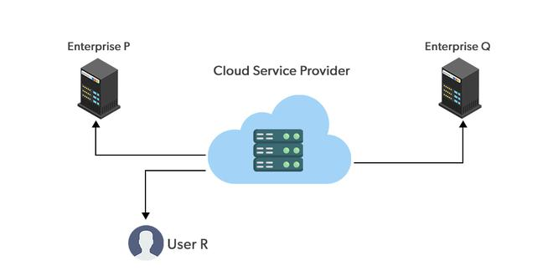
Advantages of the Public Cloud Model
- Minimal Investment: Because it is a pay-per-use service, there is no substantial upfront fee, making it excellent for enterprises that require immediate access to resources.
- No setup cost: The entire infrastructure is fully subsidized by the cloud service providers, thus there is no need to set up any hardware.
- Infrastructure Management is not required: Using the public cloud does not necessitate infrastructure management.
- No maintenance: The maintenance work is done by the service provider (not users).
- Dynamic Scalability: To fulfill your company’s needs, on-demand resources are accessible.
Disadvantages of the Public Cloud Model
- Less secure: Public cloud is less secure as resources are public so there is no guarantee of high-level security.
- Low customization: It is accessed by many public so it can’t be customized according to personal requirements.


Private Cloud
The private cloud deployment model is the exact opposite of the public cloud deployment model. It’s a one-on-one environment for a single user (customer). There is no need to share your hardware with anyone else. The distinction between private and public clouds is in how you handle all of the hardware. It is also called the “internal cloud” & it refers to the ability to access systems and services within a given border or organization. The cloud platform is implemented in a cloud-based secure environment that is protected by powerful firewalls and under the supervision of an organization’s IT department. The private cloud gives greater flexibility of control over cloud resources.
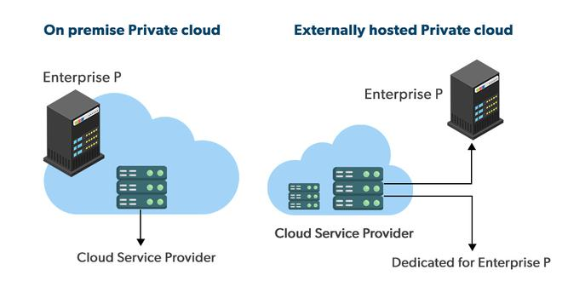
Advantages of the Private Cloud Model
- Better Control: You are the sole owner of the property. You gain complete command over service integration, IT operations, policies, and user behaviour.
- Data Security and Privacy: It’s suitable for storing corporate information to which only authorized staff have access. By segmenting resources within the same infrastructure, improved access and security can be achieved.
- Supports Legacy Systems: This approach is designed to work with legacy systems that are unable to access the public cloud.
- Customization: Unlike a public cloud deployment, a private cloud allows a company to tailor its solution to meet its specific needs.
Disadvantages of the Private Cloud Model
- Less scalable: Private clouds are scaled within a certain range as there is less number of clients.
- Costly: Private clouds are more costly as they provide personalized facilities.

Hybrid Cloud
By bridging the public and private worlds with a layer of proprietary software, hybrid cloud computing gives the best of both worlds. With a hybrid solution, you may host the app in a safe environment while taking advantage of the public cloud’s cost savings. Organizations can move data and applications between different clouds using a combination of two or more cloud deployment methods, depending on their needs.
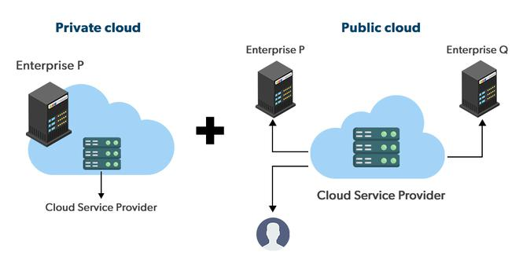
Advantages of the Hybrid Cloud Model
- Flexibility and control: Businesses with more flexibility can design personalized solutions that meet their particular needs.
- Cost: Because public clouds provide scalability, you’ll only be responsible for paying for the extra capacity if you require it.
- Security: Because data is properly separated, the chances of data theft by attackers are considerably reduced.
Disadvantages of the Hybrid Cloud Model
- Difficult to manage: Hybrid clouds are difficult to manage as it is a combination of both public and private cloud. So, it is complex.
- Slow data transmission: Data transmission in the hybrid cloud takes place through the public cloud so latency occurs.

Community Cloud
It allows systems and services to be accessible by a group of organizations. It is a distributed system that is created by integrating the services of different clouds to address the specific needs of a community, industry, or business. The infrastructure of the community could be shared between the organization which has shared concerns or tasks. It is generally managed by a third party or by the combination of one or more organizations in the community.
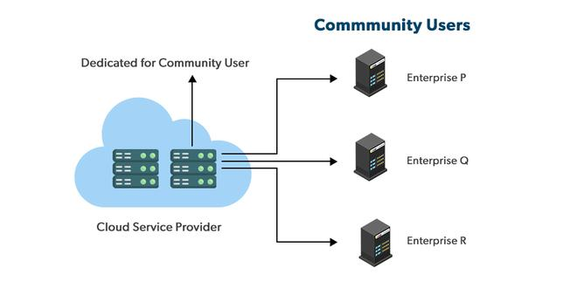
Advantages of the Community Cloud Model
- Cost Effective: It is cost-effective because the cloud is shared by multiple organizations or communities.
- Security: Community cloud provides better security.
- Shared resources: It allows you to share resources, infrastructure, etc. with multiple organizations.
- Collaboration and data sharing: It is suitable for both collaboration and data sharing.
Disadvantages of the Community Cloud Model
- Limited Scalability: Community cloud is relatively less scalable as many organizations share the same resources according to their collaborative interests.
- Rigid in customization: As the data and resources are shared among different organizations according to their mutual interests if an organization wants some changes according to their needs they cannot do so because it will have an impact on other organizations.

Multi-Cloud
We’re talking about employing multiple cloud providers at the same time under this paradigm, as the name implies. It’s similar to the hybrid cloud deployment approach, which combines public and private cloud resources. Instead of merging private and public clouds, multi-cloud uses many public clouds. Although public cloud providers provide numerous tools to improve the reliability of their services, mishaps still occur. It’s quite rare that two distinct clouds would have an incident at the same moment. As a result, multi-cloud deployment improves the high availability of your services even more.
Advantages of the Multi-Cloud Model
- You can mix and match the best features of each cloud provider’s services to suit the demands of your apps, workloads, and business by choosing different cloud providers.
- Reduced Latency: To reduce latency and improve user experience, you can choose cloud regions and zones that are close to your clients.
- High availability of service: It’s quite rare that two distinct clouds would have an incident at the same moment. So, the multi-cloud deployment improves the high availability of your services.
Disadvantages of the Multi-Cloud Model
- Complex: The combination of many clouds makes the system complex and bottlenecks may occur.
- Security issue: Due to the complex structure, there may be loopholes to which a hacker can take advantage hence, makes the data insecure.
What is the Right Choice for Cloud Deployment Model?
As of now, no such approach fits picking a cloud deployment model. We will always consider the best cloud deployment model as per our requirements. Here are some factors which should be considered before choosing the best deployment model.
- Cost: Cost is an important factor for the cloud deployment model as it tells how much amount you want to pay for these things.
- Scalability: Scalability tells about the current activity status and how much we can scale it.
- Easy to use: It tells how much your resources are trained and how easily can you manage these models.
- Compliance: Compliance tells about the laws and regulations which impact the implementation of the model.
- Privacy: Privacy tells about what data you gather for the model.
Each model has some advantages and some disadvantages, and the selection of the best is only done on the basis of your requirement. If your requirement changes, you can switch to any other model.

Overall Analysis of Cloud Deployment Models
The overall Analysis of these models with respect to different factors is described below.
Factors | Public Cloud | Private Cloud | Community Cloud | Hybrid Cloud
Initial Setup | Easy | Complex, requires a professional team to setup | Complex, requires a professional team to setup | Complex, requires a professional team to setup
Scalability and Flexibility | High | High | Fixed | High
Cost-Comparison | Cost-Effective | Costly | Distributed cost among members | Between public and private cloud
Reliability | Low | Low | High | High
Data Security | Low | High | High | High
Data Privacy | Low | High | High | High

Cloud Architecture
Cloud architecture refers to the design and structure of systems, applications, and services that operate in a cloud computing environment. It defines how different cloud components—such as storage, networking, computing, and security—are arranged to meet an organization's requirements.
Key Components of Cloud Architecture
- Front-End (Client Side)
  - Includes web browsers, mobile apps, or desktop applications.
  - Interfaces with cloud services via APIs or cloud-based applications.
- Back-End (Cloud Infrastructure)
  - Compute: Virtual machines (VMs), containers, or serverless computing.
  - Storage: Block storage (e.g., AWS EBS), object storage (e.g., Amazon S3), and databases.
  - Networking: Virtual Private Cloud (VPC), Content Delivery Networks (CDN), and Load Balancers.
  - Security: Identity and Access Management (IAM), firewalls, encryption, and monitoring.
- Cloud Delivery Models
  - Infrastructure as a Service (IaaS): Provides virtualized computing resources (e.g., AWS EC2, Google Compute Engine).
  - Platform as a Service (PaaS): Provides a platform for application development (e.g., AWS Elastic Beanstalk, Google App Engine).
  - Software as a Service (SaaS): Delivers fully managed software applications (e.g., Google Workspace, Microsoft 365).
- Deployment Models
  - Public Cloud: Services offered by third-party providers (e.g., AWS, Azure, Google Cloud).
  - Private Cloud: Dedicated infrastructure for a single organization.
  - Hybrid Cloud: Combination of public and private cloud.
  - Multi-Cloud: Use of multiple cloud providers for different services.
- Scalability and Elasticity
  - Horizontal Scaling: Adding more instances.
  - Vertical Scaling: Upgrading the existing instance's resources.
  - Auto-Scaling: Automatically adjusting resources based on demand.
- Microservices and Serverless Computing
  - Microservices: Application architecture where services are loosely coupled.
  - Serverless: Executes code without managing infrastructure (e.g., AWS Lambda, Azure Functions).
- Security and Compliance
  - Data Encryption: Protects data in transit and at rest.
  - Access Control: IAM policies to restrict access.
  - Compliance: Ensuring adherence to regulations like GDPR, HIPAA.
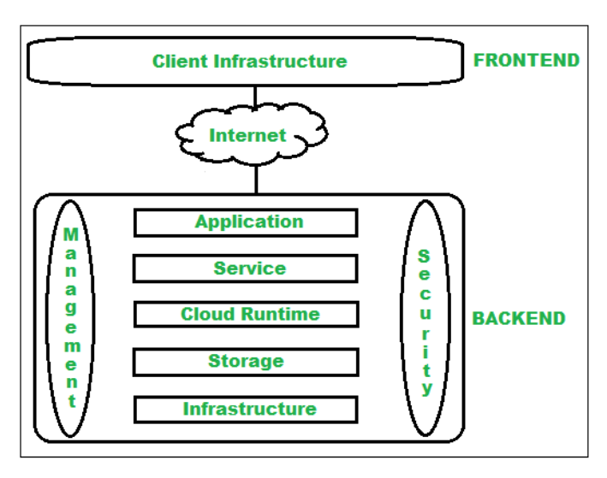

Infrastructure as a Service (IaaS)
IaaS provides virtualized computing resources over the internet, allowing businesses to scale up without managing physical hardware. Below is a typical IaaS cloud architecture with key components.
IaaS Cloud Architecture Diagram Overview
A well-structured IaaS architecture typically includes:
1️ Compute Layer (Virtual Machines & Containers)
- Virtual Machines (VMs) hosted on cloud providers (e.g., AWS EC2, Google Compute Engine, Azure Virtual Machines).
- Containerized workloads using Docker and Kubernetes.
- Auto-scaling groups to handle demand changes dynamically.
2️ Storage Layer
- Block Storage: Persistent storage for VMs (AWS EBS, Azure Disk Storage).
- Object Storage: Scalable data storage for unstructured data (AWS S3, Google Cloud Storage).
- File Storage: Shared network file systems (Amazon EFS, Azure Files).
3️ Networking Layer
- Virtual Private Cloud (VPC) for isolated network environments.
- Load Balancer to distribute traffic across multiple instances.
- Content Delivery Network (CDN) for fast global access (CloudFront, Azure CDN).
4️ Security & Compliance
- Identity & Access Management (IAM) for user authentication.
- Firewall & Security Groups to control traffic.
- DDoS Protection using services like AWS Shield.
- Monitoring & Logging (AWS CloudWatch, Azure Monitor, GCP Stackdriver).
5️ Management & Automation
- Infrastructure as Code (IaC) using Terraform, CloudFormation.
- Configuration Management (Ansible, Puppet, Chef).
- CI/CD Pipelines for automated deployment.

Deployment Example (AWS IaaS)
EC2 Instances (Compute)
Elastic Load Balancer (ELB)
S3 Storage for Backups
VPC for Secure Networking
IAM for Access Control
CloudWatch for Monitoring

Platform as a Service (PaaS)
PaaS provides a managed platform for developers to build, test, and deploy applications without managing the underlying infrastructure. It abstracts infrastructure complexities, offering a scalable and automated environment.
PaaS Cloud Architecture Overview
A typical PaaS architecture includes:
1️ Application Hosting & Compute
- Managed runtime environments for applications.
- Examples: AWS Elastic Beanstalk, Google App Engine, Azure App Services.
- Supports multiple programming languages (Node.js, Python, Java, etc.).
- Auto-scaling to handle traffic spikes automatically.
2️ Storage & Databases
- Managed Databases: AWS RDS, Azure SQL Database, Google Cloud SQL.
- Object Storage: AWS S3, Google Cloud Storage, Azure Blob Storage.
- NoSQL Databases: Firebase, DynamoDB, CosmosDB.
3️ Networking & Load Balancing
- Load Balancer: Distributes traffic to backend services.
- CDN (Content Delivery Network) for global performance.
- API Gateway for secure API management.
4️ Security & Identity Management
- Identity & Access Management (IAM) for authentication.
- OAuth & OpenID Connect for user authentication (Firebase Auth, AWS Cognito).
- DDoS Protection using cloud-native security tools.
5️ DevOps & Automation
- CI/CD Pipelines: GitHub Actions, Jenkins, GitLab CI/CD.
- Infrastructure as Code (IaC): Terraform, CloudFormation.
- Monitoring & Logging: AWS CloudWatch, Azure Monitor, Google Operations Suite.

Deployment Example (AWS PaaS)
AWS Elastic Beanstalk (Automated app hosting)
AWS RDS (Managed relational database)
Amazon S3 (Object storage)
Amazon API Gateway (Secure API access)
AWS Lambda (Serverless backend functions)
AWS IAM & Cognito (Identity & access management)

Software as a Service (SaaS)
SaaS is a cloud-based software delivery model where applications are hosted and managed by a provider and accessed by users via a web browser or API. This eliminates the need for users to install or maintain software on their devices.

A typical SaaS architecture consists of multiple layers:
1️ Multi-Tenant Application Layer
- Multi-Tenancy: A single application instance serves multiple customers (tenants).
- Scalability: Auto-scaling mechanisms ensure smooth performance under varying loads.
- Isolation: Logical or physical isolation of customer data for security.
- Examples: Google Workspace, Dropbox, Salesforce.
2️ Compute & Hosting
- Hosted on cloud platforms (AWS, Azure, Google Cloud).
- Containers & Kubernetes (Docker, AWS ECS, GKE) for efficient workload management.
- Serverless Computing (AWS Lambda, Azure Functions) for microservices-based SaaS.
3️ Storage & Databases
- Relational Databases: AWS RDS, Google Cloud SQL, Azure SQL Database.
- NoSQL Databases: DynamoDB, Firebase, CosmosDB for scalability.
- Object Storage: AWS S3, Azure Blob Storage for user-generated content.
4️ API & Integration Layer
- API Gateway for secure API exposure (AWS API Gateway, Azure API Management).
- Webhooks & SDKs for third-party integrations.
- Microservices Architecture for modular development.
5️ Security & Access Control
- Identity & Access Management (IAM) (AWS IAM, Azure AD).
- OAuth & SSO (Okta, Auth0, Firebase Authentication).
- DDoS Protection & Encryption (AWS Shield, TLS Encryption).
6️ DevOps & Monitoring
- CI/CD Pipelines (GitHub Actions, Jenkins, AWS CodePipeline).
- Infrastructure as Code (IaC) (Terraform, CloudFormation).
- Logging & Monitoring (AWS CloudWatch, Azure Monitor).

Deployment Example (AWS SaaS)
Amazon ECS (Containers) / AWS Lambda (Serverless Backend)
Amazon RDS (Database) / DynamoDB (NoSQL Data Storage)
Amazon S3 (File Storage for User Data)
Amazon API Gateway (RESTful APIs)
AWS Cognito (User Authentication & Authorization)

Storage as a Service (STaaS)
Storage as a Service (STaaS) is a cloud-based solution where businesses and individuals can store, manage, and retrieve data over the internet without maintaining physical storage infrastructure. It provides scalable, on-demand storage with high availability, security, and redundancy.
A well-structured STaaS architecture consists of multiple layers:
1️ Storage Types & Use Cases
- Object Storage (e.g., AWS S3, Google Cloud Storage, Azure Blob Storage)
  - Best for unstructured data, media files, backups, and logs.
- Block Storage (e.g., AWS EBS, Azure Disk Storage, Google Persistent Disk)
  - Used for databases and virtual machine (VM) storage.
- File Storage (e.g., Amazon EFS, Azure Files, Google Filestore)
  - Ideal for shared access and enterprise file management.
- Backup & Archival Storage (e.g., AWS Glacier, Azure Archive Storage)
  - Cost-effective for long-term data retention.
2️ Compute & Storage Infrastructure
- Distributed Storage Architecture
  - Data replication across multiple regions for redundancy.
  - Erasure coding and sharding for data integrity.

- Storage Virtualization
  - Abstracts physical storage to optimize efficiency.
- Edge Storage
  - Caches frequently accessed data closer to users for better performance.
3️ Data Access & Networking
- RESTful APIs & SDKs for seamless application integration.
- CDN (Content Delivery Network) for faster data retrieval.
- Storage Gateway for hybrid cloud storage access.
4️ Security & Compliance
- Data Encryption (AES-256, TLS/SSL for data in transit & at rest).
- IAM & Access Policies (Role-based access control, SSO).
- Data Loss Prevention (DLP) to prevent accidental deletions.
- Compliance Standards (GDPR, HIPAA, SOC 2).
5️ Management & Monitoring
- Automated Storage Tiering (Moving cold data to lower-cost storage).
- Data Lifecycle Policies (Retention, deletion, and archival rules).
- Monitoring & Logging (AWS CloudWatch, Azure Monitor).

Deployment Example (AWS STaaS)
Amazon S3 (Object Storage for applications & backups)
Amazon EBS (Block Storage for EC2 instances)
Amazon EFS (File Storage for shared access)
AWS Storage Gateway (Hybrid cloud integration)
AWS Glacier (Archival storage for cost optimization)
AWS IAM & KMS (Security, access control & encryption)

Communication as a Service (CaaS)
Communication as a Service (CaaS) is a cloud-based model that provides real-time communication services such as voice, video, messaging, and APIs to businesses without requiring them to build and maintain their own communication infrastructure.
A CaaS architecture includes multiple layers to enable seamless communication across different channels:
1️ Core Communication Services
- Voice over IP (VoIP) → Cloud-based voice calling (e.g., Twilio, Zoom, RingCentral).
- Video Conferencing → WebRTC-based services (e.g., Zoom, Google Meet, Microsoft Teams).
- Messaging & Chat → SMS, MMS, and instant messaging (e.g., WhatsApp API, Slack, Telegram).
- Email & Notifications → Transactional emails & push notifications (e.g., SendGrid, Firebase Cloud Messaging).
2️ Cloud Infrastructure & Compute
- Hosted on public cloud providers (AWS, Azure, Google Cloud).
- Auto-scaling & Load Balancing for handling spikes in communication traffic.
- Edge Servers & CDNs for low-latency global communication.
3️ Networking & API Integration
- SIP (Session Initiation Protocol) for VoIP call handling.
- WebRTC for peer-to-peer audio & video communication.
- RESTful APIs & SDKs for third-party integration (e.g., Twilio API, Vonage, AWS Chime).
- Chatbots & AI Assistants for automation (e.g., Dialogflow, Amazon Lex).
4️ Security & Compliance
- End-to-End Encryption (E2EE) for secure messaging & video calls.
- Multi-Factor Authentication (MFA) for identity verification.
- DDoS Protection & Firewalls for network security.
- Compliance Standards → GDPR, HIPAA, SOC 2 for secure communication.
5️ Monitoring & Analytics
- Real-Time Call & Message Tracking → Usage statistics & performance monitoring.
- AI-Powered Transcription & Sentiment Analysis for customer interactions.
- Cloud-Based Call Recording & Storage for compliance & training.

Deployment Example (AWS CaaS)
Amazon Chime (Video conferencing & VoIP)
Amazon SNS (Push notifications & messaging)
Amazon Connect (Cloud-based contact center)
AWS Lambda & API Gateway (Backend communication logic)
Amazon KMS (Encryption for secure communication)
CloudWatch & AWS X-Ray (Monitoring & performance tracking)

Monitoring as a Service (MaaS)
Monitoring as a Service (MaaS) is a cloud-based model that provides real-time monitoring, alerting, and analytics for IT infrastructure, applications, and security without requiring organizations to maintain their own monitoring solutions. It helps businesses track performance, detect anomalies, and optimize resources.
A well-structured MaaS architecture includes multiple layers:
1️ Data Collection & Ingestion
- Agent-Based Monitoring → Installed on servers, VMs, or containers (e.g., Prometheus Node Exporter, Datadog Agents).
- Agentless Monitoring → Uses APIs, logs, or network polling (e.g., AWS CloudWatch, Azure Monitor).
- Log Management → Centralized collection of logs from applications, servers, and network devices (e.g., ELK Stack, Splunk, AWS CloudTrail).
2️ Cloud Infrastructure & Compute
- Hosted on public cloud platforms (AWS, Azure, Google Cloud).
- Edge Computing for monitoring IoT and distributed systems.
- Auto-scaling to handle large volumes of monitoring data.
3️ Data Processing & Storage
- Time-Series Databases (e.g., InfluxDB, Prometheus) for tracking performance metrics.
- Big Data Processing (e.g., Apache Kafka, AWS Kinesis) for handling high-velocity logs.
- AI & ML-Based Anomaly Detection (e.g., AWS Lookout, Azure Sentinel).
4️ Visualization & Reporting
- Dashboards & Alerts (e.g., Grafana, Kibana, AWS CloudWatch).
- Automated Reports for historical trend analysis.
- Custom Querying via APIs for advanced analytics.
5️ Security & Compliance
- IAM & Role-Based Access Control (RBAC) to restrict access.
- SIEM (Security Information & Event Management) tools for threat detection (e.g., Splunk, IBM QRadar).
- Compliance Monitoring (GDPR, HIPAA, SOC 2) for regulatory audits.
6️ Incident Management & Automation
- AI-Powered Incident Response (e.g., PagerDuty, Opsgenie).
- Automated Remediation (Self-healing infrastructure using AWS Lambda, Azure Automation).
- Integrations with ITSM Tools (e.g., ServiceNow, Jira).

Deployment Example (AWS MaaS)
Amazon CloudWatch (Metrics, logs, and alerts)
AWS X-Ray (Application performance monitoring)
AWS CloudTrail (User activity tracking)
AWS Security Hub (Threat monitoring & compliance)
Amazon OpenSearch (Elasticsearch) (Log analysis)
AWS Lambda (Automated responses & anomaly detection)

Everything as a Service (XaaS)
Everything as a Service (XaaS) is a broad cloud computing model that delivers any IT function as a service over the internet. This includes infrastructure, platforms, software, security, storage, and even business processes, making it a fully managed, subscription-based, and scalable approach for businesses.
A well-structured XaaS architecture integrates multiple cloud service models:
1️ Infrastructure as a Service (IaaS) → Compute & Storage
- Compute: Virtual machines, containers, and serverless computing (AWS EC2, Azure VMs, Google Compute Engine).
- Storage: Object, block, and file storage (AWS S3, Google Cloud Storage, Azure Blob Storage).
- Networking: Load balancers, VPNs, and CDNs (AWS CloudFront, Azure Traffic Manager).
2️ Platform as a Service (PaaS) → Development & Integration
- Application Hosting: Managed cloud platforms (AWS Elastic Beanstalk, Google App Engine).
- Database Services: Managed relational & NoSQL databases (AWS RDS, Firebase, CosmosDB).
- Serverless Functions: Event-driven execution (AWS Lambda, Azure Functions).
3️ Software as a Service (SaaS) → End-User Applications
- Business Applications: CRM, ERP, Office Suites (Salesforce, Google Workspace, Microsoft 365).
- Collaboration Tools: Cloud-based communication platforms (Slack, Zoom, Microsoft Teams).
- Data Analytics & AI: Cloud-based AI services (AWS SageMaker, Google Vertex AI).
4️ Security as a Service (SECaaS) → Cybersecurity & Compliance
- Identity & Access Management (IAM): Secure authentication (AWS IAM, Azure AD, Okta).
- DDoS Protection & Firewalls: Cloud-based security solutions (AWS Shield, Cloudflare, Palo Alto Prisma).
- SIEM & Threat Detection: Monitoring & anomaly detection (Splunk, AWS Security Hub).
5️ Communication as a Service (CaaS) → Voice, Video, Messaging
- VoIP & Video Conferencing: Cloud-based communication (Zoom, Twilio, AWS Chime).
- Messaging APIs: SMS, email, and chatbots (Firebase Cloud Messaging, SendGrid).
6️ Storage as a Service (STaaS) → Data Management & Archival
- Backup & Disaster Recovery: Cloud-based backups (AWS Backup, Azure Site Recovery).
- Cold Storage & Archiving: Low-cost long-term data retention (AWS Glacier, Azure Archive Storage).
7️ Monitoring as a Service (MaaS) → IT Performance Tracking
- Infrastructure Monitoring: Cloud performance dashboards (AWS CloudWatch, Azure Monitor).
- Log Management & SIEM: Security monitoring & analytics (Datadog, ELK Stack, Splunk).
8️ Business Process as a Service (BPaaS) → Automation & Workflows
- Robotic Process Automation (RPA): Automating workflows (UiPath, AWS Step Functions).
- IT Service Management (ITSM): Cloud-based IT support tools (ServiceNow, Jira Service Desk).
Deployment Example (AWS XaaS)
Amazon EC2 / Lambda (Compute Infrastructure - IaaS)
AWS RDS / DynamoDB (Managed Databases - PaaS)
Amazon WorkSpaces (Virtual Desktops - DaaS)
Amazon Connect (Cloud Contact Center - CaaS)
Amazon S3 & Glacier (Cloud Storage - STaaS)
AWS CloudWatch (Monitoring & Alerts - MaaS)
AWS IAM & Security Hub (Identity & Security - SECaaS)
AWS SageMaker (AI & Machine Learning - AIaaS)

Benefits of XaaS
Scalability → Pay-as-you-go with flexible resource scaling.
Cost-Effective → No upfront infrastructure investment.
Automation & AI → Intelligent monitoring & self-healing systems.
Security & Compliance → Cloud-native security solutions.

Cloud Service Providers (CSP)
Cloud Service Providers (CSPs) are companies that offer cloud computing services, including Infrastructure as a Service (IaaS), Platform as a Service (PaaS), and Software as a Service (SaaS). These services provide on-demand computing power, storage, networking, databases, AI, security, and more.

Major Cloud Service Providers
The top CSPs globally include:
Cloud Provider | Key Services | Strengths
Amazon Web Services (AWS) | EC2 (VMs), S3 (Storage), RDS (Databases), Lambda (Serverless) | Largest cloud provider, broadest services
Microsoft Azure | Azure VMs, Blob Storage, Azure SQL, Functions | Best for enterprise & hybrid cloud solutions
Google Cloud Platform (GCP) | Compute Engine, Cloud Storage, BigQuery, AI & ML | Strong AI, analytics, and Kubernetes support
IBM Cloud | IBM Cloud Virtual Servers, Watson AI, Cloud Foundry | AI-powered cloud services & hybrid cloud
Oracle Cloud | Oracle Cloud Infrastructure (OCI), Autonomous DB | Best for databases & enterprise apps
Alibaba Cloud | ECS, OSS, PolarDB, AI Cloud | Leading provider in Asia-Pacific markets
Salesforce Cloud | CRM, Sales, Marketing & Service Cloud | Best for SaaS-based customer relationship management
DigitalOcean | Droplets, Spaces (Object Storage), Kubernetes | Best for developers & startups
Tencent Cloud | CVM, COS, AI, WeChat Cloud | Strong presence in China & gaming industry

- Advantages and Disadvantages of Cloud Computing

Cloud computing has revolutionized how businesses and individuals use technology by providing on-demand access to computing resources over the internet. However, it comes with both benefits and challenges.
Advantages of Cloud Computing
1️ Cost Savings
No Upfront Infrastructure Costs – Businesses avoid purchasing expensive hardware and software.
Pay-as-You-Go Model – Users only pay for the resources they use.
Reduced IT Maintenance Costs – No need to maintain physical servers and data centers.
2️ Scalability & Flexibility
On-Demand Resource Allocation – Scale computing power up or down as needed.
Global Reach – Cloud providers have data centers worldwide for high availability.
Supports Business Growth – Start small and expand without infrastructure limitations.
3️ Performance & Reliability
High Uptime – Cloud providers offer 99.9%+ availability (AWS, Azure, GCP).
Load Balancing – Distributes traffic to optimize performance.
Disaster Recovery – Data replication and backup solutions ensure business continuity.
4️ Security & Compliance
Data Encryption – Protects sensitive information in transit and at rest.
IAM & Access Control – Role-based security prevents unauthorized access.
Regulatory Compliance – GDPR, HIPAA, SOC 2, ISO 27001 certifications.
5️ Faster Deployment & Innovation
Rapid Application Deployment – Deploy new apps in minutes.
AI & Machine Learning Integration – Easily access advanced analytics and AI tools.
Collaboration & Remote Work – Employees can work from anywhere with cloud-based tools.

Disadvantages of Cloud Computing
1️ Security & Privacy Concerns
Data Breaches & Cyberattacks – Cloud environments are prime targets for hackers.
Shared Responsibility Model – Users must secure their applications and data.
Lack of Control – Cloud providers manage security patches and updates.
2️ Downtime & Internet Dependency
Service Outages – Even major providers (AWS, Azure, GCP) experience downtime.
High Latency – Performance issues may arise due to network connectivity.
Internet-Dependent – No cloud access without a stable internet connection.
3️ Hidden Costs & Vendor Lock-In
Unexpected Costs – Data transfer, API calls, and extra storage can be expensive.
Migration Complexity – Moving from one cloud provider to another can be costly and time-consuming.
Limited Customization – Some cloud solutions don’t offer deep customization options.
4️ Compliance & Legal Issues
Data Residency & Sovereignty Issues – Certain industries require data to be stored in specific regions.
Cloud Provider Policies – Users must comply with provider-specific regulations.

